Impact of Birds and Spiders on Butterfly Abundance and Diversity on Saipan and Guam
Alexandra Kerr, Christina Tudela, Ray Hiroshi
Abstract
Birds and spiders are both predators of butterflies at all stages of its life cycle. Comparison of butterfly population on Guam and Saipan was carried out in order to see if there was a difference in butterfly abundance and diversity in an ecosystem with birds and and ecosystem without birds. We predicted that butterfly abundance and diversity would be greater on Guam. To test this, we observed and recorded the number of butterflies and spiders along a transect line at three sites each on Guam and Saipan. Our results suggest that the difference in butterfly population between Guam and Saipan is only marginally significant. However, there was still observed to be a difference in the abundance of butterflies and species variation between the two islands. Butterfly population and diversity was lower on Saipan. Our results show a positive correlation between butterfly abundance and spider abundance, the more butterflies there are, the more spiders there are. A more detailed study of butterfly abundance comparison between Guam and Saipan is needed in order to find out more about the impact of birds and spiders on butterflies in the region.
Introduction
Butterflies have many predators including other insects such as wasps and ants; reptiles; mammals; and birds (Schreiner and Nafus, 1997). The question of whether or not birds are predators of butterflies became a controversial issue at the turn of the 20th century, but has since been answered by several studies that involve observations of beak marks on wings (Carpenter,1942). There has been found to be more frequent bird predation on butterflies than formerly thought, and additionally, there is a significant increase in bite marked wings of species that deter predators by being poisonous, suggesting that more palatable species are successfully eaten (Carpenter, 1942). More recently, field studies of bird predation show a large frequency of predation on butterflies (Pough and Brower, 1977; Sakurai, 2011; Alonso-Mejia, et. al., 1998). Studies of bird predation on butterflies also suggest enough pressure on natural selection of butterfly morphology. Monarchs in Oahu, Hawaii have developed two separate wing-color morphs, white and orange. The selection for white morphs is correlated with the presence of the introduced bulbul, Pycnonotus jacosus and Pycnonotus cafer (Stimson and Berman, 1990). What is less studied is the impact of multiple predators on the population of a single prey. Spiders are also a predator of butterflies, but are known to be generalists, feeding on multiple types of prey (Nyffeler, 1999). Hooks, Pandey and Johnson (2003) found that both birds and spiders decrease caterpillar population through predation, but do not exert any significantly increased predation together than when separated; however, birds were more destructive to caterpillar populations than spiders.
The impacts of bird predation and spider predation on butterfly populations have not been widely studied. The Marianas ecosystem presents an ideal location for studying these effects. On Guam, the introduced brown tree snake, Boiga irregularis, has decimated the native bird population, thus relieving butterflies of a natural top predator. This situation presents a unique opportunity to compare the butterfly population of an ecosystem without a usual top predator, with a comparable ecosystem that includes the top predator. Saipan maintains a native bird population and has similar habitat types compared to Guam. One survey of rare butterflies in the Marianas has been conducted, and it includes a general population survey of all butterflies observed in a wide range of habitats on Guam, Rota, and Saipan (Schreiner and Nafus, 1996). However, the butterfly populations recorded on Guam and Saipan cannot be compared due to huge differences in habitat, date, and duration of each place surveyed. Our study seeks to find a possible impact of bird presence and spider presence on butterfly populations. Here, we compare the amount of butterflies and spiders on Saipan, where there is a high bird population, to Guam, which has experienced an immense decrease in bird population. We tested our question by walking along a transect line at several sites on both islands and recording the amount of butterflies and spiders we observed. We predict that butterfly abundance has increased on Guam, but experiences a decrease in abundance in the presence of spiders.
Methods Section
Study Sites
This study was conducted on the islands of Guam and Saipan, in the Mariana island chain in the western Pacific ocean. Saipan and Guam have the same butterfly species, 20 species in all, with 10 species that are found readily around the islands (Schreiner and Nafus, 1997). Most butterfly species found on Guam and Saipan are widely distributed throughout the world, while there are only three types of butterflies believed to be specific to the Micronesian region (Schreiner and Nafus, 1997).
Sites chosen were limestone secondary forest roads with a presence of tangantangan, Leuceana leucocephala, vegetation. The three sites selected on Saipan were at Naftan Point (N 15°06.911', E 145°45.104'), Marpi (N 15°15.709'/E 145°49.240'), and Tanke (N 15°15.160'/E 145°47.753). The three sites selected on Guam were Two Lovers Point (N 13°32.048'/ E 144°48.373'), Anao (N 13°32.601'/ E 144°55.337'), and Pagat (N 13°29.990'/ E 144°52.633').
Surveys
Each site was surveyed twice within a three day period for each island. The surveys were conducted between 10:00 a.m. and 4:30 p.m. each day. For each site, time and weather were recorded at the start of transect. Global Position Satellite (GPS) location was taken at the beginning and end of transect. Three surveyors completed each transect. One surveyor’s task was to spot and identify butterflies, another surveyor recorded each butterfly sighted by the first surveyor, and another surveyor spotted and tallied spider presence. Any butterfly that could not be easily identified was captured and then identified. Observations were continued along transect for about 0.4 miles, except at Anao where the transect was 0.34 miles since the trail became obstructed by dense vegetation. Pace was relatively constant at all sites so that redundant observations would not be made. At the end of the first transect for each site, transect tape was used to mark the end of the trail to ensure the second survey ended at the same point.
Analysis
The abundance of butterflies was compared between islands using a linear regression model. Variations of butterfly population and diversity between sites on each island were also compared. To see if there is a correlation between spider abundance and butterfly abundance, a linear regression model was used to calculate the p-value and r²-value.
Results
For Saipan, we recorded 6 species of butterflies along our transects and a total of 323 butterflies, mainly of the species Eurema blanda (Boisduval) of the Family Piéridae. Guam exhibited a higher butterfly population, with 10 recorded species and a total of 555 butterflies, consisting mostly of Papilio polytes (L.), a species in the Papilionidae family. However, there was only a marginally significant difference (p =0.05083) between butterfly abundance on Saipan and Guam. The three surveying days on Saipan were relatively dry and sunny while the three surveying days on Guam were rainy and mostly cloudy. At the Anao transect on Guam, one specimen of the rare subspecies Hypolimnas octocula mariannensis (Butler) of the Family Nymphalidae was spotted. The invasive Chilades pandava (Horsefield) of the family Lycaenidae was also recorded as abundant at the Anao transect. Immediately following the transect at Two Lovers Point (TLP) on our second trip, we encountered a grove of African Tulip trees (Spathodea campanulata) where more than 50 Euplaoa eunice (Godart) of the Danaidae family were seen resting on the branches. No congregating behavior in E. eunice was observed on Saipan.
The number of spiders recorded in Saipan was 332, while Guam projected a total of 685 spiders. No correlation between spider population and butterfly population was found on Saipan. On Guam, we observed that the higher the spider population along a transect, the higher the butterfly population as well. To test for a significant correlation between the occurrence of butterflies and spiders, we used a linear regression model. Spider population and butterfly population showed a positive correlation on Guam (adjusted r²_{adj.}= 0.7579; p=0.015;F_{1,4}=16.65; n=6).

Fig. 1. Butterfly abundance average between islands
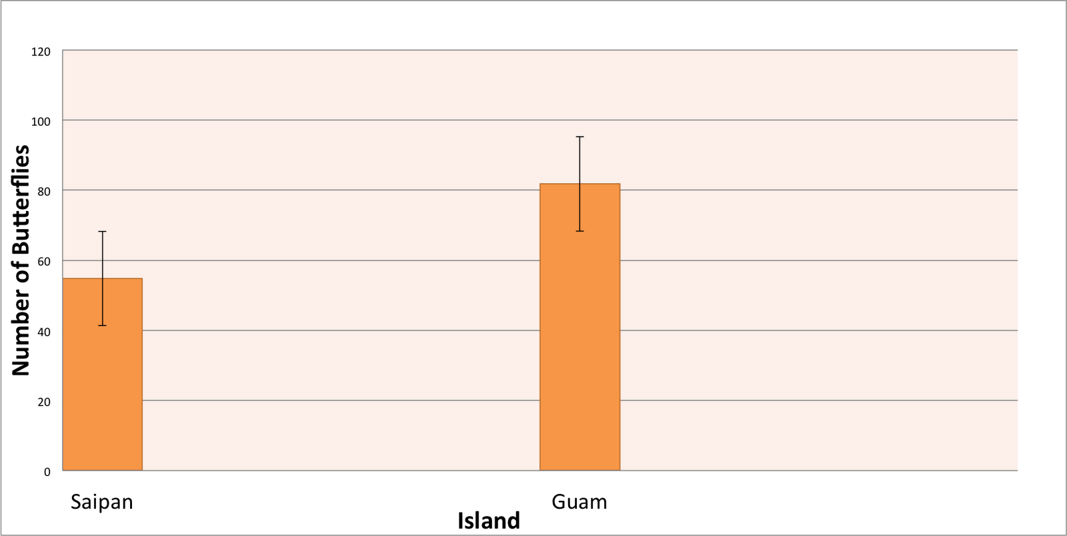

Fig. 2. Comparison of Butterfly species spotted on Saipan and Guam
 | Saipan | Guam
Danaidae
Euploea eunice | x | x
Danaus plexippus | · | x
Lycaenidae
Chilades pandava | · | x
Nymphalidae
Hypolimnas anomola | x | x
Hypolimnas bolina | x | x
Hypolimnas octocula | · | x
Papilionidae
Papilio polytes | x | x
Pieridae
Eurema blanda | x | x
Catopsilia pomona | · | x
Satyridae
Melanitis leda | x | x

Fig. 3. Spider/Butterfly abundance Guam 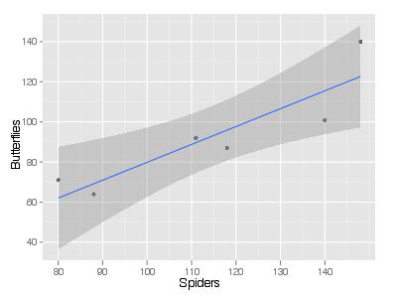
Discussion
Comparisons on the simple food web interactions among birds, spiders and butterflies in Saipan and Guam show that bird presence is a marginally significant factor in butterfly abundance on Saipan. while the results of spider abundance compared to butterfly abundance on Guam show a positive correlation. Our hypothesis that Guam would have a greater butterfly abundance was not conclusively proved, but it may mean that birds do not play a major role in the predation of butterflies. The results of butterfly abundance and spider abundance were opposite of what we predicted. We thought that as spider abundance increases, butterfly abundance will decrease. The results suggest that spiders do not play a major predatory role on butterflies on Guam. Birds likely play more of a role on butterfly mortality than spiders (Hooks, Pandey, and Johnson, 2003). These results may also suggest that general arthropod mortality is decreased on Guam. Birds are also natural predators of spiders (Gannarsson, 2008). Increased abundance of arthropods may have an impact on Guam vegetation. Without bird predation, folivores, which includes butterfly larvae, show a pronounced impact on leaf destruction (Lichtenberg and Lichtenberg, 2002). Another interesting comparison between Guam and Saipan is the marked difference in the amount of spiders, and the size of spiders and webs. At two sites on Guam, spiders were observed feeding on E. blanda and an unidentified butterfly. This behavior was not seen on Saipan. We noticed that webs on Guam, as well as being more abundant, are bigger. Webs found along the transects in Saipan, however, did not seem big enough to catch butterflies. Therefore, spider predation of butterflies may still occur more on Guam than on Saipan.
Several confounding factors we encountered during the study may have affected our results, and better control of these variables may offer better results if this study were to be replicated. We had surveyed sites twice, but butterfly populations at each site stayed relatively stable between each observation day. It was good to ensure we controlled for variation between different days on the same site, but if, instead, we had surveyed more areas, more data could have been collected and the results may have been more conclusive. Differences in weather may also account for butterfly numbers. Although it didn’t rain during any transect surveys, early morning rain, and continued cloudy weather on Guam may have kept butterflies from being active, and therefore, seen.
It was a challenge to find comparable sites on Guam and Saipan since butterflies are mainly host specific and abundance can be affected by presence of a host plant. Saipan sites mainly consisted of tangantangan trees while Guam sites were more disturbed with less tangantangan cover. The TLP trail had a noticeable abundance of lemondechina, Triphasia trifolia, which was seen to attract P. polytes (L.) Similarly in Saipan, E. blanda was recorded in abundance at Marpi. This may also have been due to the abundance of its host plant, although we were not able to identify what that would be. Contrarily, a common butterfly on Guam and Saipan, Hypolimnas bolina (L.), is considered to be polyphagous, not preferring any one plant to feed on (Schreiner and Nafus, 1997). This butterfly was observed less times than P. polytes, but was seen in more places, especially on Saipan. Perhaps surveys should avoid areas of high host plant density. These observations would need to be taken into account in further studies.
This study leaves open the possibility for more research on the possible impacts of bird presence and spider presence on butterfly populations. Additionally, studies on other predators at different trophic levels may offer a better understanding of butterfly predation. Lizards are another predator we did not account for in this study (Odendaal, Rausher, Benrey, and Nunez-Farfan, 1987; Ehrlich and Ehrlich, 1982). It would be interesting to see what other predators (arthropods, mammals, reptiles, parasitoids) may be filling the predatory role left by birds on Guam. One interesting note in the difference of butterfly populations on Guam and Saipan was an observed difference in the frequency of the intensity of the white spots on Hypolymnas anomola (Wallace). On Guam there seems to be more of an abundance of intense white markings on the wings of this butterfly. We were unable to tally this frequency in the present study, but it would be interesting to see if bird predation or the absence of bird predation has impacted the morphology of butterflies by comparing the morphology of a particular species, such as H. anomola, on Guam and Saipan. To better understand butterflies and their place as prey in the food web, a more in-depth study, to include more sites, is recommended.

References
Alonso-Mejia A., Montesinos-Patino E., Rendon-Salinas E., Brower L. P., and Oyama, K. 1997. Influence pf [sic] forest canopy closure on rates of bird predation on
overwintering Monarch Butterflies Danaus plexippus L. Biological Conservation. 85:151-159.
Carpenter, G. D. 1942. The relative frequency of beak-marks on butterflies of different edibility to birds. Proceeding of the Zoological Society of London. A111(3-4): 223-231.
Ehrlich P. R. and Ehrlich A. H., 1982. Lizard predation on tropical butterflies. Journal of the Lepidopterists’ Society. 36(2): 148-152.
Gunnarsson, B. 2008. Bird predation on spiders: Ecological mechanisms and evolutionary consequences. The Journal of Arachnology 35: 509-529.
Hooks, R. R. C., Pandey R.R., and Johnson M. W., 2003. Impact of avian and arthropod predation on lepidopteran caterpillar densities and plant productivity in an ephemeral agroecosystem. Ecological Entomology. 28(5): 522-532.
Lichtenberg J. S. and Lichtenberg D. A., 2002. Weak trophic interactions among birds, insects and Whit Oak sapling (Quercus alba). American Midland Naturalist. 148(2) 338-349.
Odendaal F. J., Rausher M. D., Benrey B., and Nunez-Farfan J., 1987. Predation by Anolis Lizard on Buttas philenor raises questions about butterfly mimicry systems. Journal of the Lepidopterist’s Society. 41(3): 141-144.
Nyffeler, M., 1999. Prey selection of spiders in the field. Journal of Arachnology. 27(1): 317-324.
Pough F. H. and Brower L., 1977. Predation by birds on Great Southern White Butterflies as a function of palatability, sex, and habitat. American Midland Naturalist. 98(1):0-58.
Sakurai R., 2011. Field observation of predation on adult lepidopterans by the tree
sparrow Passer montanus saturatusens. Entomological Science.14:162-165.
Schreiner I.H. and Nafus D.M., 1996. Survey of rare butterflies in the Marianas Islands. Preliminary report. U.S. Fish and Wildlife Service unpublished report. 10pp.
Schreiner I.H. and Nafus D.M., 1997. Butterflies of Micronesia. Agricultural experiment station college of agriculture and life sciences. University of Guam. Mangilao, Guam. 30pp.
Stimson, J. and Berman M., 1990. Predator induced colour polymorphism in Danaus plexippus L. (Lepidoptera: Nymphalidae) in Hawaii. Heredity. 65: 401-406.

